**CST8253 Web Programming II**

Lab 7

# Objective

1. Use ASP.NET TextBox, RadioButton, Checkbox and Table web controls.

# Due Date

See Canvas posting for the due date of this lab. To earn 5 points, you are required:

1. Complete the lab as required.
2. Zip the web site folder (the folder containing your web site) and submit the zipped file to the Canvas.
3. Demo your lab work during the following week’s lab session.

**Requirements**

Start with the partial completed website, **Lab 7** to create an ASP.NET website for online course registration. This website has one ASP.NET web page CourseRegistration.aspx. This ASP.NET web page should have the following behaviors:

Note:

* Open the website by selecting Visual Studio menu **File > Open > Web Site …** browsing and openning the folder containing App_Code, App_Theme:

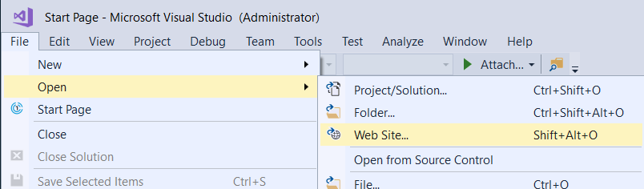

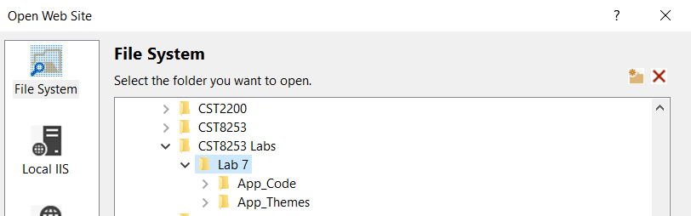

* Study and use the supplied CSS file “SiteStyles.css” in App_Theme folder to style your web page. **It is required to style your web page**.
* Use *GetAvailableCourses*( ) method of the **Helper** class defined in App_Code folder to get a list of available courses.
* Study and use the classes **Course**, **Student**, **FullTimeStudent**, **PartTimeStudent** and **CoopStudent** defined in Entities folder inside App_Code folder to complete your implementation of the web page’s code-behind.

1. On initial load, the page presents the user: (see sample page below)

* A text box to enter his/her name.
* A three radio buttons to select student type from **full time**, **part time** or **co-op**.
* A checkbox list for course currently available for registration.
* A submit button to submit the registration.

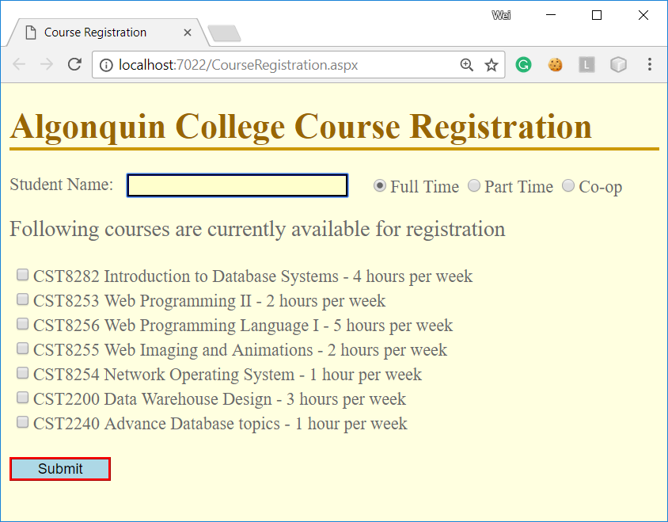

1. Once the user entered his/her name, selected the course(s) to register and clicked the “Submit” button, the web application validate the student’s request against the following registration rules:

* Full time students – cannot exceed 8 hours in a week.
* Part time students – cannot register more than 2 courses;
* Coop students – cannot register more than 2 courses or exceed 4 hours in a week

If the validation fails, the page presents an error message to the user:

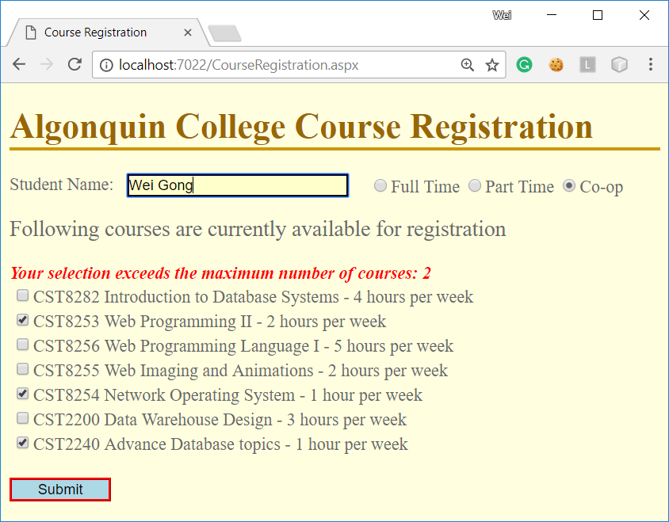

1. If the validation is successful, the user will be presented with the following confirmation page:

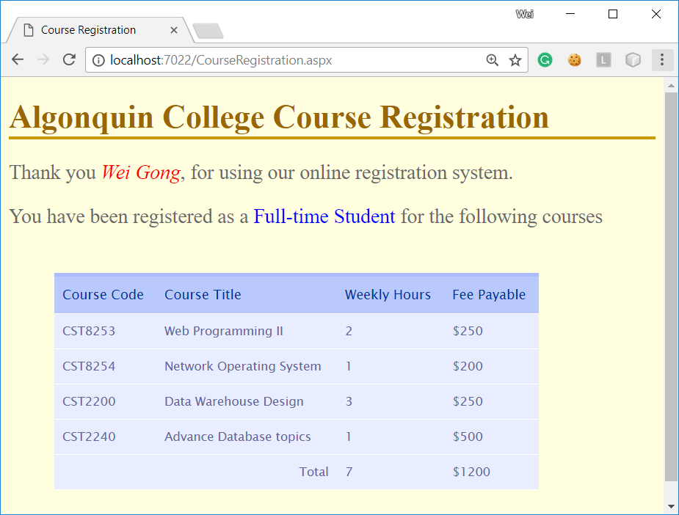

Note:

On this page, it is required to have the following elements:

* The name of the student.
* The type of the student.
* A table lists all courses the students selected, the total weekly hours and total tuition payable.
* The tuition payable for full-time and part-time students is the total of all the fees of registered courses. The tuition payable for co-op students will include a Co-op fee in addition to the fees of registered courses.